IFG Adventure 3rd Year Pacificz
Term Two – Week Eight
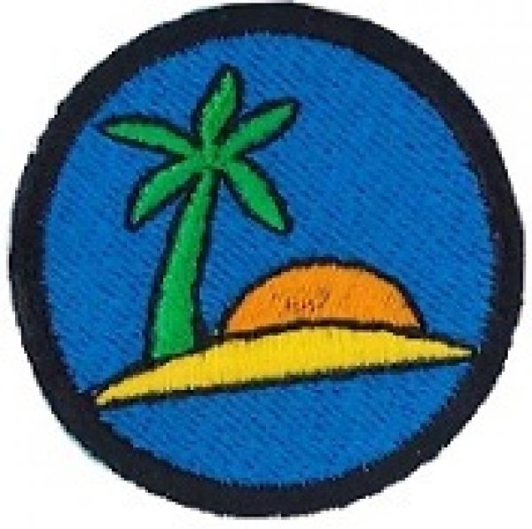
Aim: To learn about some Pacific Island Countries.
Note: There are some extra resources at the end of this section on the Pacific.

Objectives:
- Share information on some Pacific Island Countries
- Invite a speaker who can tell the girls about a Pacific Island
- Teach the girls how to weave

Preparation:
- Source a speaker to share information with the girls on Pacific Island countries OR gather together information that you can share – information on Tonga, Solomon Islands and Niue is attached.
- Atlas or map of the world
- Copies of the worksheets if you choose to use them.

Set-up:
Usual set up, roll call etc.

Devotions:
Object: Bag of sugar. Sugar cane is grown on many Pacific islands.
Lesson: Ask girls to count things in the room. E.g. shoes, people wearing glasses, hats etc. now count grains of sugar.

Bottom line: You can’t count how much God loves you.

Teaching Session:
Introduction:
Girls’ Brigade (sister organisation of IFG) is found in 10 Pacific Island Countries, they are American Samoa, Australia, Cook Islands, New Zealand, Niue, Papua New Guinea, Solomon Islands, Tonga, Tuvalu and Vanuatu. Using a map, show the girls where these countries are in relation to New Zealand. Attached to this programme are the flags of these countries to show the girls.
There is also a word find on the Islands and other Pacific things, one on Niue, and information on the Coconut crab.

Introduce the visitor/speaker and provide the girls with an outline for the evening’s programme e.g.
- Visitor / Speaker will share information
- Girls will have the opportunity to ask questions.
- Visitor will then teach the girls how to weave

OR if you are taking this part of the programme yourself, use the information attached or source your own. Here are some good websites: Cook Islands http://www.ck/
Vanuatu http://vanuatu.travel/ ; Papua New Guinea http://www.pngtourism.org.pg/

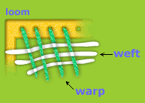
Teach the girls how to weave – here are some ideas:
Weaving:
What is weaving?
Weaving is the process of making cloth. Cloth is made by crossing two sets of threads over and under each other. The two sets of threads are called warp and weft.
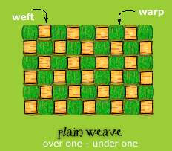
There are many different types of weaves. Some are plain and some are fancy, but all use the basic “under and over” technique of weaving. Here are a few illustrations of the basic types of weaves.

Plain weave is the simplest weave. Notice the weft goes over one warp and then under one warp.

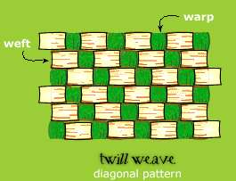
Twill weave produces a strong, sturdy fabric like denim used for jeans. In a twill weave, the weft passes over several warp threads to produce a diagonal pattern

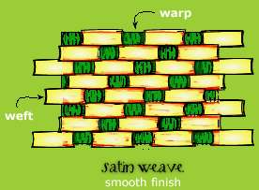
A satin weave will produce a smooth, luxurious cloth. The weft can pass over as many as 12 warp threads so that the diagonal line cannot be seen. Satin weave can be snagged very easily.

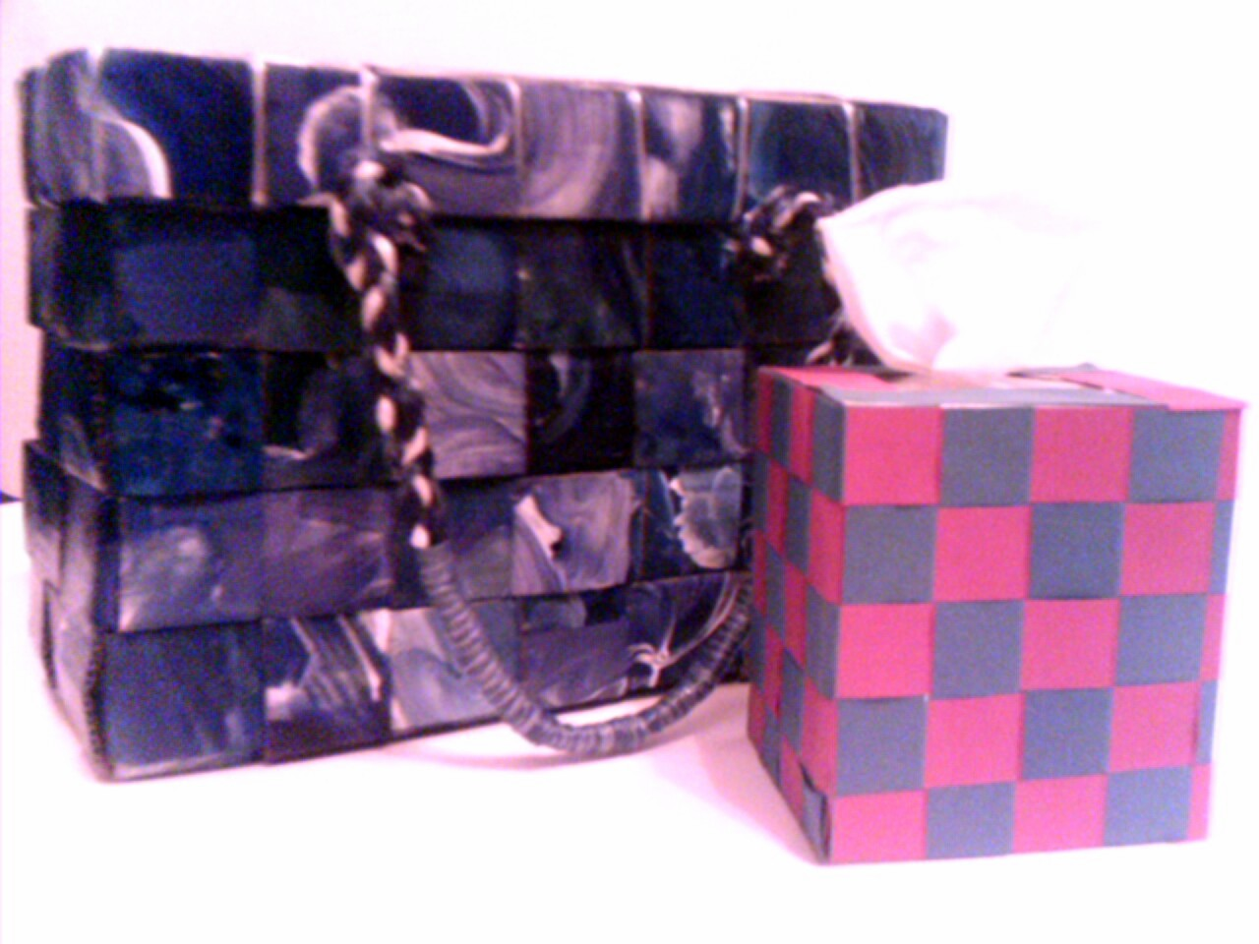
The Pandanus plant is used for weaving in Tonga. These plants are grown near to the village so that there will be a ready supply of raw materials. The women wear a Kie Kie which is waist mat and the men a ta’ovala waist mat over their tupenu (dark wrap-around skirt)
Tourists often buy woven products for souvenirs, such as baskets, purses, hats, tablemats and trays. You can use natural materials such as our New Zealand flax or strips of coloured paper to weave. Ideas for weaving could be making simple bookmarks, placemats, tissue box covers or baskets.

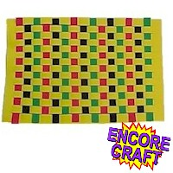
Woven placemat
Equipment:
30cm x 46cm Piece of Yellow Craft Foam
23cm x 30cm Craft Foam: Red, Black and Green
Tacky Glue or Glue Dots
Scissors
Instructions:
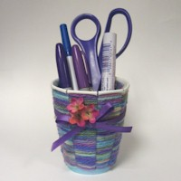
Mark off 2.5 from both ends of the 30cm x 46 cm craft foam sheet and cut a lengthwise slit every 2 ½ cm being careful to end slits at the 2 ½ cm mark. Cut black, red and green foam stock into 2 ½ x 30 cm strips. Weave strips in through the slits alternating each row. Secure ends with glue or glue dots.

Stationery holder
Equipment:
Paper Cup
Scissors
Variegated Yarn
Ribbon
Silk Flowers
Glue
Instructions:
Cut slits down the paper cup until you reach the bottom. The number of cuts needs to be an odd number. Our cup has 7 slits spaced 2.5 cm apart. Begin wrapping the yarn in and out of the cup prongs starting at the bottom. Continue wrapping, pushing the yarn snug against the row below it. When you reach the top, trim. Tie a piece of ribbon around the cup, gluing in place. Add a few silk flowers.

Here are two other weaving activities:
